**SYSTEM REQUIREMENTS**

**PROBLEM STATEMENT:**

Insufficient income gained by farmers in agriculture produce.

**FUNCTIONS PROVIDED:**

1. Easy communication for dissemination of information about price, volume and others.

2. Post-harvest loss can be minimized by selling their produce by this platform.

3. Transparency in activities will be provided by the system.

4. Bargaining power improved of farmers.

**PROCESSING ENVIORNMENT:**

SOFTWARE:

1. Sublime Text Editor
2. ReactJS (Facebook framework)
3. Wamp server
4. Mysql Database
5. Web Browser

**USER CHARACTERISTICS:**

FARMER:

1. REQUEST THE TRADER FOR SELLING THE AGRICULTURE PRODUCE.
2. NEGOTIATE WITH TRADER FOR POR SELLING PRODUCE.
3. GET INFORMATION OF THE PROPORTIONS OF THE FERTILIZERS REQUIRED FOR THE SOIL AS PER THE CROP.
4. GET INFORMATION ABOUT GOVERNMENT SCHEMES

TRADER:

1. DIRECTLY COMMUNICATE WITH THE FARMER.
2. GET AGRICULTURE PRODUCE OF THE DESIRED QUALITY.

**SOLUTION STRATEGY**

By making this Business Application Software, traders and farmers will get a platform for selling produce.

**PRODUCT FEATURES:**

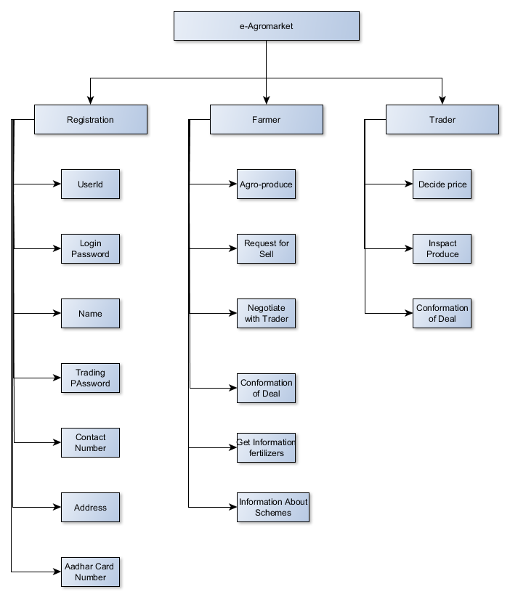

PROTOTYPE:

This will contains registration module and platform for online trading and will function for just one district.

MODEST:

This will have bug fixes of previous versions and will be implemented in one state.

ENHANCED VERSION:

Will be further enhanced and function for whole India.

**SOURCES OF INFORMATION:**

Various farmer organization of their states’ API will be integrated in our application.

Governments Sites like Agmarknet.gov.in , Khudut Mitra, APMC will be source of Govt. Schemes.

**TEAM STRUCTURE**

MITUL – BACKEND

NIYAT- FRONTEND

SHYAM- DATABASE DEVELOPMENT AND BACKEND